

- 2026)
V Deepak
2520030503
CSE
CO-1 Tress & Balanced Search Structures

Case Study Topic: Tour Plan Destination Management using AVL Tree
Work Done Summary
In this case study, we implemented an AVL Tree for the Tour Plan Smart Tourism & Travel Itinerary Optimization System. The AVL Tree stores Destination IDs of tourist attractions, historical sites, and travel locations in a balanced structure to enable efficient searching, insertion, and deletion operations. The system automatically performs tree rotations to maintain balance after each update, ensuring fast access to destination information and optimized itinerary management
Implementation Details:
- Inserted Route IDs into AVL Tree.
- Maintained balanced structure using rotations.
- Performed searching operations efficiently.
- Displayed sorted travel schedules using inorder traversal.
Result: Screenshot/ Output
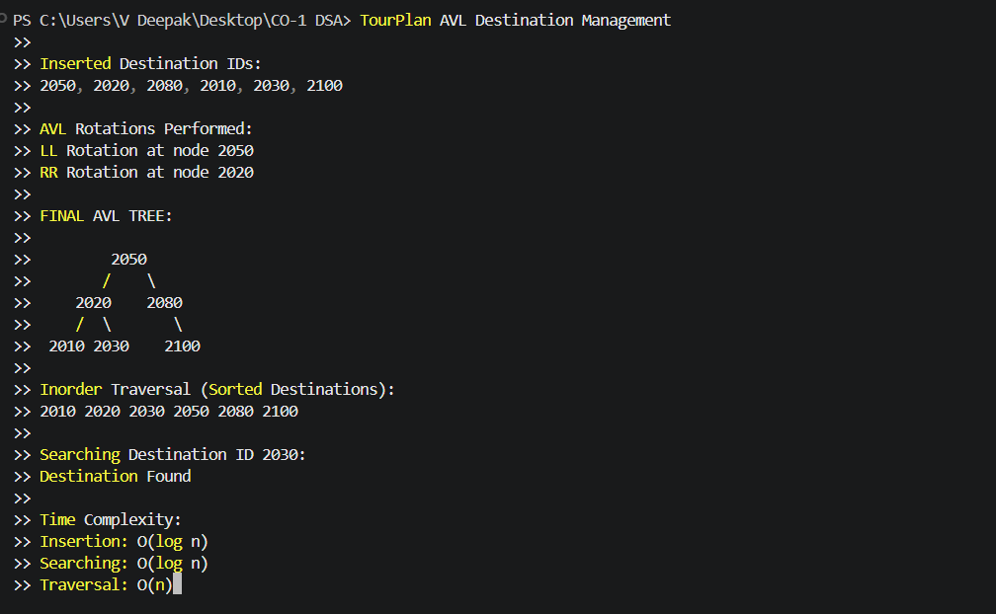
GitHub Link:

